TumorTech AI-Powered Brain Tumor Analysis with Predictive Algorithms



Project Advisor: Ma'am Sara Fareed

Submitted By

Bushra Aslam F22BINFT1E02075


Department of Information Technology (DIT)

THE ISLAMIA UNIVERSITY OF BAHAWALPUR
TumorTech AI-Powered Brain Tumor Analysis with Predictive Algorithms

By

Bushra Aslam

Project submitted to Ma’am Sara Fareed

Department of Information Technology,

The Islamia University of Bahawalpur.

in partial fulfillment of the requirements for the degree of

BACHELOR OF SCIENCE
IN
INFORMATION TECHNOLOY (BSIT)

Supervisor Signature | In- Charge Examination Signature

Chairman, Department of Information Technology

THE ISLAMIA UNIVERSITY OF BAHAWALPUR

ACKNOWLEDGEMENT

I would like to express my sincere gratitude to Ma’am Sara Fareed, Project Supervisor, The Islamia University of Bahawalpur, for her valuable guidance, support, and encouragement throughout this project.
I am also thankful for the assistance and cooperation provided during the course of this work, which greatly contributed to its successful completion. Finally, I would like to thank my family and friends for their constant support, motivation, and encouragement throughout this project.

Date:
June 04, 2026

ABSTRACT

Brain tumor detection through MRI scans is a critical yet time-consuming task requiring expert analysis. This project, TumorTech, presents an AI-powered web-based system designed to automate the detection and classification of brain tumors using Convolutional Neural Networks (CNNs).The main objective is to assist healthcare professionals by providing quick and accurate tumor identification. Users can upload MRI scans through an intuitive interface, after which the system preprocesses the images, analyzes them using a trained deep learning model, and generates a downloadable diagnostic report with tumor details and confidence scores.We used supervised deep learning with a labeled MRI dataset. The model was developed in Python using TensorFlow, while Fast-API served as the backend and ReactJS powered the frontend. MongoDB was used to store and manage image data securely.Initial testing shows high accuracy in identifying tumor types such as glioma, meningioma, and pituitary tumors, reducing diagnostic time significantly. The system supports efficient decision- making in clinical settings and can be especially beneficial where access to radiologists is limited.While promising, the system currently supports only MRI and depends on pre-trained models. Future improvements include expanding to real-time processing, additional imaging types, and deeper system integration within hospital environment.

Table of Contents

Chapter 01

Gathering and Analyzing Information 08
  - Introduction 08
  - Project Title 08
  - Project Overview Statement 08
  - Project Goals & Objectives… 09
  - High-level System Requirements… 09
  - List of Optional Functional Units… 10
  - Exclusions… 11
  - Application Architecture 11
  - Gantt chart… 15
  - Hardware and Software Specifications… 16
  - Tools & Techniques used with reasoning… 17
Chapter 2
Software Requirements Specification 20
  - Methodology… 20
  - Functional Requirements… 22
  - Non-Functional Requirements… 24
  - Hardware Requirements… 26
Chapter 3
Analysis 28
  - Use Case Diagrams 28
  - Use Case Scenario 29
Chapter 4
Design 33
  - Class Diagram… 33
  - Sequence Diagram… 35
  - ER Diagram… 38
  - Data Schema… 39
  - Architectural Diagram… 39
Chapter 5
Graphical User Interface 42
  - GUI 42
Chapter 6
Testing 46
  - Introduction… 46
  - Test Scenario… 46
  - Test Plan… 48
Chapter 7
Future Work & Conclusion 49
  - Future Work 49

Introduction

Brain tumors, resulting from uncontrolled cell growth in the brain, pose serious health risks, potentially leading to life-threatening conditions. While MRI is a preferred non-invasive method for tumor diagnosis, manual interpretation of these images is labor-intensive, requiring expert analysis and often leading to errors due to variations in tumor characteristics. The high volume of MRI data further strains radiologists, complicating timely and precise diagnoses. AI advancements, particularly in deep learning with Convolutional Neural Networks (CNNs), have greatly enhanced the field of medical imaging by automating image analysis. CNNs can identify complex patterns within MRI scans, offering improved accuracy, efficiency, and support for healthcare professionals by reducing diagnostic time and facilitating faster clinical decisions.

Project Title

TumorTech AI-Powered Brain Tumor Analysis with Predictive Algorithms

Project Overview Statement

The "Brain Tumor Detection Using MRI Images" project aims to create an AI-based system that automates the detection and classification of brain tumors in MRI scans. Using Convolutional Neural Networks (CNNs), a type of deep learning, the system will identify different types of tumors like glioma, meningioma, and pituitary adenomas, as well as distinguish healthy brain tissues. This non-invasive tool reduces the need for manual interpretation, making diagnoses faster, more accurate, and less costly. By aiding healthcare professionals in early detection, this project supports timely medical interventions and aims to improve patient outcomes.

Project Goals & Objectives

Goals
    - Develop an AI-based system for accurate tumor detection in MRI and CT scans.
    - Enhance diagnostic accuracy to improve patient outcomes and healthcare efficiency.
    - Provide an intuitive user interface for healthcare professionals to easily upload and analyze medical images.

Objectives
    - Preprocess medical images to prepare them for deep learning algorithms.
    - Train a deep learning model for tumor classification using labeled datasets.
    - Create a user-friendly web application for image uploads and result retrieval.
    - Enable quick and accurate diagnostic results to support timely treatment decisions.

High-level system components

Image Upload Module
      - Interface for users to upload MRI or CT images.
      - Support for multiple image formats.

Deep Learning Model
      - AI algorithms for tumor detection and classification.
      - Model training on preprocessed medical image datasets.

Image Preprocessing Module
      - o Techniques for enhancing image quality and preparing images for analysis.
      - Segmentation methods to isolate areas of interest.

REST API
      - Fast-API or Flask for serv ing the deep learning model. o Endpoints for image submission and result retrieval.

User Interface (UI)
      - ReactJS-based interface for user interaction.
      - Displays diagnostic results and provides navigation features.

Results Analysis Module
      - Interpretation of AI-generated results and classifications.
      - Visualizations to aid healthcare professionals in understanding the outputs.

Database Management
      - Secure and efficient access to stored data.

List of optional functional units

Performance Optimization
Performance improvements, such as faster response times and better handling of large datasets, could be achieved through model tuning and high-performance computing but may require specialized expertise and longer development time.

Ease of Use & Learning
Adding features like tutorials and guided navigation can simplify user interaction, making the system more intuitive, but this requires user feedback and additional development resources.

Quality Management
Incorporating robust QA processes ensures model accuracy and system reliability but may extend development timelines due to additional testing and validation efforts.

Scalability for Large-Scale Deployment
Scaling the system for broader use in hospitals or clinics requires cloud infrastructure and thorough testing to maintain performance under increased loads, necessitating more resources.

Exclusions

    - Support for Other Imaging Modalities: The project focuses exclusively on MRI and CT scans for tumor detection. Ultrasound, PET scans, or X-ray imaging will not be included due to the project scope and time constraints.

    - Custom Model Training by Users: Users will not be able to train custom AI models within the platform. The project will utilize pre-trained models to maintain consistency and reliability in diagnostic accuracy.

    - Real-time Image Analysis: The system will not offer real-time analysis due to computational limitations. Image processing will be conducted after the upload, requiring a short processing time.

Application Architecture

Client Layer (Front-End)

    - Technology: ReactJS
    - Function: The user interface (UI) where healthcare professionals upload MRI scan images and view the results of the analysis. o Components:
- Image upload feature (via the browser).
- Visualization of the results (detection outcomes, tumor classification).

API Layer (Back-End)
    - Technology: Fast-API
    - Function: This layer handles communication between the front-end and the machine learning model. It processes the images uploaded from the front-end and returns the model’s output to the client.

Machine Learning Layer (AI/ML Model)
    - Technology: TensorFlow, PyTorch (for training and inference), Google Colab (for model development)

    - Function: The core of the application where the trained deep learning model processes the images and provides tumor detection and predictive analysis.

Data Layer (Storage and Database)

    - Technology: MongoDB (for image storage)
    - Function: Handles the storage of MRI scan images and any related metadata.

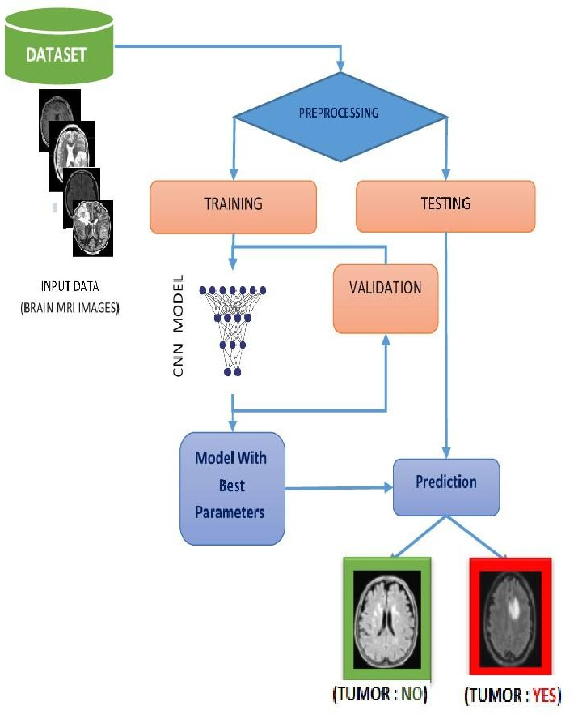

Figure: 1.1 Brain Tumor Detection Using CNN Model

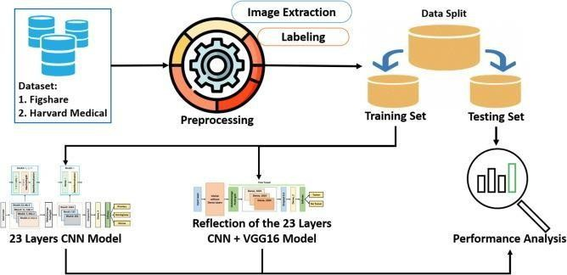

Figure: 1.2 Deep Learning Framework for Image Classification

Gantt-chart

Task No. | Task Name | Start Date | End Date | Duration | Progress (%)
1 | Setup version control (Git) | 2024-11-01 | 2024-11-11 | 7 days | 5%
2 | Data Collection | 2024-11-11 | 2024-11-18 | 6 days | 10%
3 | Data Preprocessing | 2024-11-18 | 2024-12-16 | 21 days | 30%
4 | Model Development | 2024-12-16 | 2025-02-07 | 40 days | 60%
5 | Model Evaluation | 2025-02-05 | 2025-02-24 | 14 days | 70%
6 | API Development | 2025-02-24 | 2025-03-10 | 11 days | 75%
7 | User Interface (UI) Development | 2025-03-07 | 2025-03-20 | 10 days | 80%
8 | Deployment | 2025-03-20 | 2025-03-31 | 8 days | 90%
9 | Final Evaluation | 2025-04-01 | 2025-04-25 | 19 days | 100%

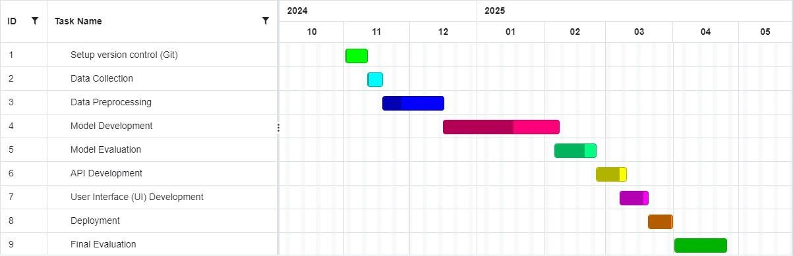

Figure: 1.3 Gantt-chart

Hardware and Software Specification

Hardware Specifications:

    - Processor: Intel Core i7 or higher for faster model training and processing.
    - RAM: Minimum 16GB for handling large datasets and deep learning computations.
    - Storage: At least 500GB SSD for storing datasets and model checkpoints.
    - GPU: NVIDIA RTX 3060 or higher (CUDA enabled) for accelerated deep learning model training.
    - Network: High-speed internet connection for data access, version control, and model deployment.
    - Display: Full HD monitor for better visualization during development.

Software Specifications:

    - Operating System: Windows 10/11, Ubuntu 20.04 LTS, or macOS.
    - Deep Learning Frameworks: TensorFlow, Keras for model development.
    - Programming Languages: Python
    - Version Control: Git for managing codebase.
    - API Development: Fast-API for deploying the trained models.
    - User Interface: ReactJS with CSS frameworks like Tailwind or Bootstrap.
    - Database: MongoDB for storing data and application configuration.
    - Image Processing Libraries: OpenCV, NumPy for preprocessing medical images.
    - IDE: Visual Studio Code, PyCharm for development.

Tools and technologies used with reasoning

Frontend Technologies:

    - ReactJS
ReactJS is a powerful JavaScript library for building interactive user interfaces. It allows for creating modular and reusable components, enabling a smooth user experience and efficient development.

CSS
These CSS frameworks simplify the styling process with pre-designed classes. They help create responsive, modern, and consistent user interfaces quickly without the need for custom CSS coding.

Backend Technologies:

    - FastAPI
FastAPI is lightweight web frameworks for building REST APIs in Python. FastAPI excels with high-performance needs and automatic documentation.

TensorFlow
These are industry-leading deep learning frameworks. TensorFlow supports largescale deployments ad production readiness.

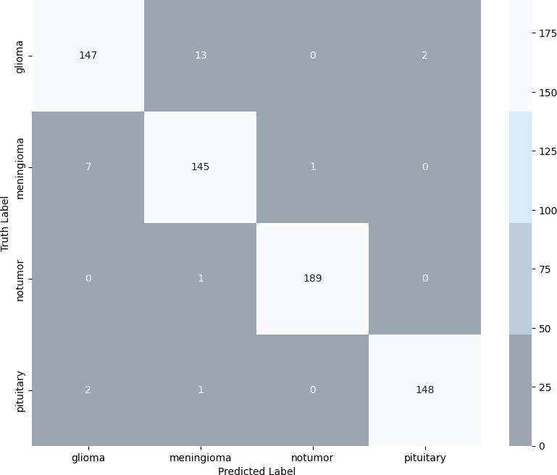

Figure 1.4: Confusion Matrix of Different Types of Tumors

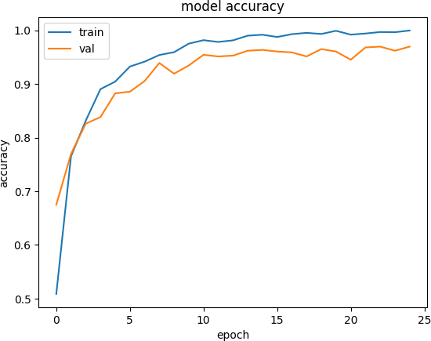
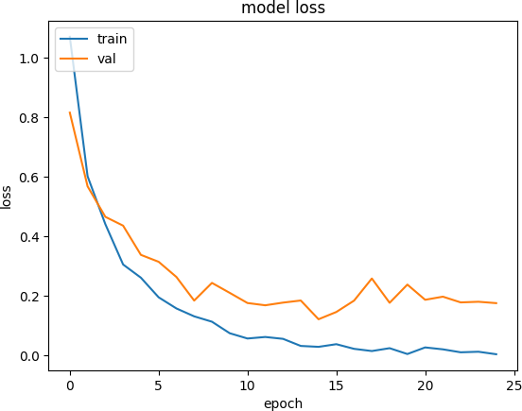

Figure 1.5: Model Accuracy and Model Loss of TumorTech

Accuracy = Total Predictions / Correct Predictions×100 Each filter performs:
Zi,j(k)=m=0∑2n=0∑2c=1∑3Xi+m,j+n(c)⋅Wm,n(c,k)+bk

Loss = −I = 1∑nyi⋅log(y^i)

Pandas
Pandas is a powerful Python library for data manipulation and analysis. In this project, it will be used for processing large datasets such as MRI or CT images, helping to prepare data for model training.

Database Technologies:

    - MongoDB
MongoDB is a flexible NoSQL database suited for storing unstructured data like MRI images. This allows efficient storage and retrieval of images for processing while maintaining connections to relevant patient and scan information.

Development and Collaboration Tools:

    - Git
Git is essential for version control, enabling collaboration between developers and tracking changes over time. It allows safe code sharing and rollback, ensuring that all team members work on the latest version of the project.

Machine Learning Development Tools:

    - Google Colab
Google Colab provides free access to GPUs and TPUs, ideal for efficiently training deep learning models. It is cloud-based, allowing real-time collaboration and easy notebook sharing. Colab supports key libraries like TensorFlow and PyTorch, essential for your project's machine learning tasks

Methodology
The methodology adopted for the TumorTech project follows a structured approach combining data collection, preprocessing, model training, system development, and testing. The core aim was to build a reliable and efficient AI-driven system capable of detecting and classifying brain tumors from MRI and CT scan images.

Data Collection:
We used a publicly available dataset containing labeled MRI images of brain tumors including glioma, meningioma, and pituitary tumors, as well as healthy scans. The dataset provided a sufficient sample size for model training and validation.

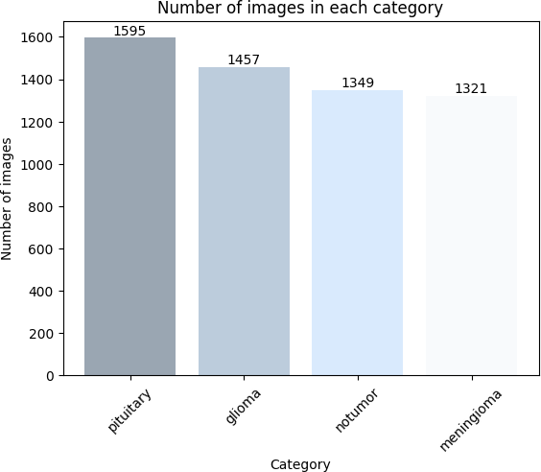

Figure 2.1: Dataset calculation Graph of different Types of Tumors

Data Preprocessing:
Uploaded images were normalized and resized to ensure consistency. Techniques like grayscale conversion, noise reduction, and contrast enhancement were applied. Data augmentation was used to improve model generalization and reduce overfitting.

Model Development:
A Convolutional Neural Network (CNN) was trained using TensorFlow in Google Colab. The architecture was fine-tuned through hyperparameter optimization, including layer configuration, dropout rates, learning rate tuning, and batch size adjustments.

System Architecture:
The backend was developed using FastAPI to handle image submissions and model predictions. The frontend was built with ReactJS for ease of use and responsiveness. MongoDB served as the database for storing uploaded scans, detection results, and reports.

Testing and Evaluation:
Functional and non-functional testing was conducted across various devices and browsers. Accuracy, performance, and user experience were evaluated. The model’s effectiveness was assessed using precision, recall, and F1-score.


Figure 2.2: TumorTech Model Accuracy

Functional Requirements

No. | Requirement | Description
FR1 | Image Upload | - Users can upload MRI or CT scan images through a user-friendly web interface.  - This functionality ensures a seamless and intuitive process for healthcare professionals to submit images for analysis.  - The system should support standard medical image formats (e.g., DICOM, PNG, JPEG) and ensure secure file transmission to protect patient confidentiality.
FR2 | Image Preprocessing | - The uploaded images undergo validation to check for compatibility, size, and format. After validation, the system normalizes these images to ensure consistency in quality and format.  - This preprocessing step may include resizing, color normalization, noise reduction, and data augmentation to prepare the images for accurate tumor detection by the deep learning  model.
FR3 | Tumor Detection | - The system employs a pre-trained deep learning model to analyze the uploaded images and detect tumor regions.  - The model identifies and highlights potential tumor areas, providing a confidence score for its findings.  - This functionality aims to assist healthcare professionals in making precise and timely diagnoses.
FR4 | Report Generation | - The system employs a pre-trained deep learning model to analyze the uploaded images and detect tumor regions.  - The model identifies and highlights potential tumor areas, providing a confidence score for its findings.  - This functionality aims to assist healthcare professionals in  making precise and timely diagnoses.

FR6 | API  Communication | - The system uses a REST API to handle communication between the frontend and backend components.  - The API processes image analysis requests and delivers results back to the frontend in real-time.  - This architecture ensures scalability, modularity, and efficient  data exchange across different system components.

Non-Functional Requirements

No. | Attribute | Description
NFR1 | Reliability | - The system must demonstrate high reliability, ensuring it can handle more than 95% of user requests without failure.  - This includes maintaining uptime, error handling, and system recovery in case of unexpected issues.  - The system should incorporate fault-tolerant mechanisms, such as redundant servers and error logging, to identify and address  problems proactively, minimizing downtime.
NFR2 | Security | To protect sensitive user and patient data, the system must implement robust security measures:  - All data, including uploaded images and analysis results, must be encrypted during transmission and storage using secure encryption standards (e.g., AES, SSL/TLS).  - User authentication is required for access to the system, with features such as encrypted passwords, session management, and multi-factor authentication (if applicable).  - Access control mechanisms should ensure that only authorized users can access specific features or data.
NFR3 | Performance | - The system must be optimized to process each image and deliver results within an average time of 10 seconds.  - This requirement ensures responsiveness and usability, particularly for healthcare professionals needing quick analysis.  - Performance optimization techniques, such as efficient algorithm implementation, caching, and load balancing, should be  employed to meet this standard.
NFR4 | Portability | - The system should be designed to operate seamlessly across  major operating systems, including Windows, Linux, and MacOS.

- This ensures accessibility for a wide range of users and devices.
- Compatibility should be achieved through platform-independent development frameworks and thorough testing on each platform.
NFR5 | Scalability | The system should support simultaneous access and processing requests from up to 50 users without performance degradation. Scalability considerations include:  - Implementing load balancing to distribute requests evenly across servers.  - Optimizing backend services to handle increased workloads.  - Ensuring the architecture can be extended to support more users if needed in the future.

Hardware Requirements

Sr# | Component | Specification | Description
1 | Processor (CPU) | Intel Core i7 or AMD Ryzen 7 (or higher) | A high-performance processor is needed to  handle complex computations and support the deep learning model efficiently.
2 | Graphics Card (GPU) | NVIDIA RTX 3060 or  higher with at least 8GB VRAM | A powerful GPU is essential for accelerating deep learning tasks, particularly for training  and inference of the model.
3 | RAM | Minimum 16 GB | Sufficient memory is required to process large medical images and run deep learning  frameworks without performance lag.
4 | Storage | Minimum 512 GB SSD | High-speed SSD storage is required for quick  access to datasets, model weights, and temporary processing files.
5 | Operating System | Windows 10/11, Linux  (Ubuntu 20.04 or newer), or macOS | The system should be compatible with widely  used operating systems for flexibility in development and deployment.
6 | Display | Full HD (1920x1080)  resolution | A high-resolution display is required for clear visualization of medical images and analysis  results.
7 | Internet Connectivity | Broadband connection with a minimum speed  of 10 Mbps | Required for accessing cloud resources, APIs, or downloading datasets and dependencies for  the project.
8 | Power Supply | 650W or higher (for desktops) | A reliable power supply unit is essential to  support the GPU and other hardware components.
9 | Peripherals | Standard keyboard and  mouse | Basic peripherals for system interaction and  testing.

Optional Hardware for Enhanced Performance
Sr# | Component | Specification | Description
1 | External Storage | 1 TB External SSD or HDD | Useful for storing large datasets or backup of medical images and analysis results.
2 | High-Performance GPU | NVIDIA RTX 3090 or NVIDIA A100 | For faster training and handling larger datasets or more complex models.

Use Case Diagrams
A simple use case diagram represents the interaction between the end user and the system, illustrating the relationship between various system operations and their functionalities. The use case identifies interactions such as uploading images, preprocessing, tumor detection, report generation, API communication, and result downloading.

Upload
Pre processing
Report
Feature processing
User
Tumor
Report generation

Figure 3.1: Use Case Diagram
Figure 1.1 illustrates the interactions between the User and the Tumor Detection System. It includes functionalities for uploading images, preprocessing, tumor detection, and generating and saving reports.

Table 3.1: Usage Scenario of Image Upload Use Case

This use case allows users to upload MRI or CT scan images to the system for analysis.

Use Case Name: Image Upload
Entry Condition: The user must select an image file to upload. | Participating Actors: End User
Flow of Events
- Basic Flow
  - The user clicks on the “Upload Image” button.
  - The user selects the image file from the local system.
  - The system validates the file type and size.
  - The system confirms successful upload.
- Alternative Flow
A1: Cancel, the system displays the message: “The upload process has been canceled by user demand.”
- Exceptional Flow
E1: Invalid file type or size, the system displays the message: “Please upload a valid MRI/CT image file.”
Exit Condition | The image is successfully uploaded and ready for preprocessing.
Constraint | The image file must be in a valid format (e.g., PNG, JPEG, DICOM) and within  size limits.

Table.3.1 showing the image is uploaded successfully if it meets the format and size requirements, ready for preprocessing. If canceled, a message notifies the user of the cancellation. Invalid file types or sizes trigger an error message, preventing further action until corrected.

Table 3.2: Usage Scenario of Image Preprocessing Use Case

This use case allows the system to preprocess uploaded images for tumor detection.

Use Case Name: Image Preprocessing
Entry Condition: An image must be uploaded to the system. | Participating Actors: End User
Flow of Events
- Basic Flow
  - The system validates the uploaded image for clarity and compatibility.
  - The system normalizes the image for analysis (e.g., resizing, color correction).
  - The system confirms successful preprocessing.
- Alternative Flow
  - A1: Cancel, the system displays the message: “Preprocessing process canceled by user demand.”
- Exceptional Flow
  - E1: Error in image quality, the system displays the message: “Image preprocessing failed due to low image quality.”
Exit Condition | The image is preprocessed and ready for tumor detection.

Table. 3.2 showing the system preprocesses the uploaded image by validating its clarity and compatibility, followed by normalization for analysis. If the user cancels, a message is displayed indicating the cancellation. In case of low image quality, the system notifies the user that preprocessing failed, and the image is not ready for tumor detection.

Table 3.3: Usage Scenario of Tumor Detection Use Case

This use case processes the uploaded image to detect tumors using the deep learning model.

Use Case Name: Tumor Detection
Entry Condition: A preprocessed image must be  available. | Participating Actors: End User
Flow of Events
- Basic Flow
  - The system sends the preprocessed image to the tumor detection model.
  - The system generates a confidence score and highlights tumor regions.
  - The model analyzes the image and identifies potential tumor regions.
- Alternative Flow
  - A1: Cancel, the system displays the message: “Tumor detection process canceled by user demand.”
- Exceptional Flow
  - E1: Model error, the system displays the message: “Tumor detection failed. Please retry.”
Exit Condition | Tumor detection results are  generated and ready for report creation.

Table. 3.3 showing the system processes the preprocessed image through the tumor detection model, generating a confidence score and highlighting potential tumor regions. If the user cancels, a message is displayed indicating the cancellation of the process. In case of a model error, the system notifies the user of the failure and prompts them to retry the detection. The tumor detection results are then ready for report generation.

Table 3.4: Usage Scenario of Report Generation Use Case

This use case generates a detailed analysis report based on tumor detection results.

Use Case Name: Report Generation
Entry Condition: Tumor detection results must be  available. | Participating Actors: End  User
Flow of Events
- Basic Flow
  - The system compiles tumor detection results, including confidence scores and tumor regions.
  - The system adds recommendations based on analysis.
  - The system generates a report in PDF format.
- Alternative Flow
  - A1: Cancel, the system displays the message: “Report generation canceled by user demand.”
- Exceptional Flow
  - E1: Report generation error, the system displays the message: “Unable to generate the report. Please retry.”
Exit Condition | A PDF report is generated and  ready for download.

The system compiles the tumor detection results, including confidence scores and identified tumor regions, and adds recommendations based on the analysis. If the user cancels the process, a message is displayed indicating the cancellation. In the case of a report generation error, the system alerts the user and prompts them to retry. Once successful, the system generates a PDF report, ready for download.

  - Class Diagram for Brain Tumor Detection System

Below is the class diagram for your system, representing key classes and their relationships:

User
username
email
contactNumber
uploadImage()
downloadReport()
Report
reportID
generateDate
reportPath
generateReport()
fetchAnalysis()

Image
ImageID
ImagePath
uploadImage
Status
validateImage()
normalizeImage()

API
apiEndpoint
apiKey
processImage()
sendImage()

Figure 4.1: Class Diagram for Brain Tumor Detection
TumorModel
modelID
Modelversion
confidenceScore
detectTumor()
analyzeImage()

Figure 4.1 shows the structure of the User, Image, API, and TumorModel classes. It outlines the attributes and methods involved in uploading images, processing them through an API, and detecting tumors using a tumor detection model.

Relationships

User and Image:
      - A User can upload Image.

Image and TumorModel:
      - An Image is processed by the TumorModel.
      - The TumorModel processes Image.

TumorModel and Report:
      - The TumorModel generates a Report for Image.

User and Report:
      - A User can download Report.

API and TumorModel:
      - The API is used to connect the TumorModel to the frontend.

Combination of Classes

Class Name | Associated  Classes | Type of Relationship | Description
User | Image,  Report | Association (1-to-  many) | A user uploads images and downloads  reports.
Image | User,  TumorModel | Association (1-to-many,  1-to-1) | An image is uploaded by a user and  processed by the tumor detection model.
TumorModel | Image, Report, API | Aggregation | The tumor model processes images and generates reports using API  communication.
Report | User, TumorModel | Association (1-to-many, 1-to-1) | Reports are generated by the tumor  model for specific images and downloaded by users.
API | TumorModel | Association (1-to-1) | The API handles communication between the frontend and the tumor  model.
This table provides a comprehensive overview of class relationships and their combinations in your system.

  - Sequence Diagram for Brain Tumor Analysis System
The User interacts with the system through the Web Interface, providing input images for tumor detection. The System (Backend) processes the input using the Tumor Detection Model to analyze and detect tumors, then generates a detailed report via the Report Generator for the user's review.

Actors:

- User
- Web Interface
- System (Backend)
- Tumor Detection Model
- Report Generator
- API






Upload Image
Upload Image()
validateImage()
NormalizeImage()
storeImage() processImage()
detectTumor()

tumorResults()
GenerateReports()
Providedowlink()
Save report
Downloadreport()
API
Tumor Detection
Backend
Web Interface
Report
User
Figure 4.2: Sequence Diagram for Brain Tumor Detection

Steps in Sequence:

User Uploads Image:
      - The User interacts with the Web Interface to upload an image.
      - The Web Interface calls the uploadImage() method to validate and upload the image to the System (Backend).

System Preprocesses Image:
      - The System (Backend) invokes the validateImage() and normalizeImage() methods on the uploaded image.
      - After validation, the image is processed and stored in the system.

Tumor Detection:
      - The System (Backend) sends the preprocessed image to the Tumor Detection Model via the processImage() method of the API.
      - The Tumor Detection Model detects tumors in the image and returns the detection results, including a confidence score and tumor regions.

Report Generation:
      - The System (Backend) sends the tumor detection results to the Report Generator via the generateReport() method.
      - The Report Generator creates a detailed analysis report, including tumor identification, confidence score, and recommendations.

Report:
      - The System (Backend) provides the Web Interface with Results.

Entity-Relationship (ER) Diagram for Brain Tumor Detection

Entities and Attributes

User
  - Attributes:
    - UserID (Primary Key)
    - Name
    - Email
    - ContactNumber

Image
  - Attributes:
    - ImageID (Primary Key)
    - UserID (Foreign Key)
    - FileName
    - UploadDate
    - Status (e.g., Pending, Processed)

Tumor Detection Result
  - Attributes:
    - ResultID (Primary Key)
    - ImageID (Foreign Key)
    - TumorDetected (Boolean)
    - ConfidenceScore
    - DetectionDate

Report
  - Attributes:
    - ReportID (Primary Key)
    - ResultID (Foreign Key)
    - FileName
    - GeneratedDate

APIRequest
  - Attributes:
    - RequestID (Primary Key)
    - ImageID (Foreign Key)

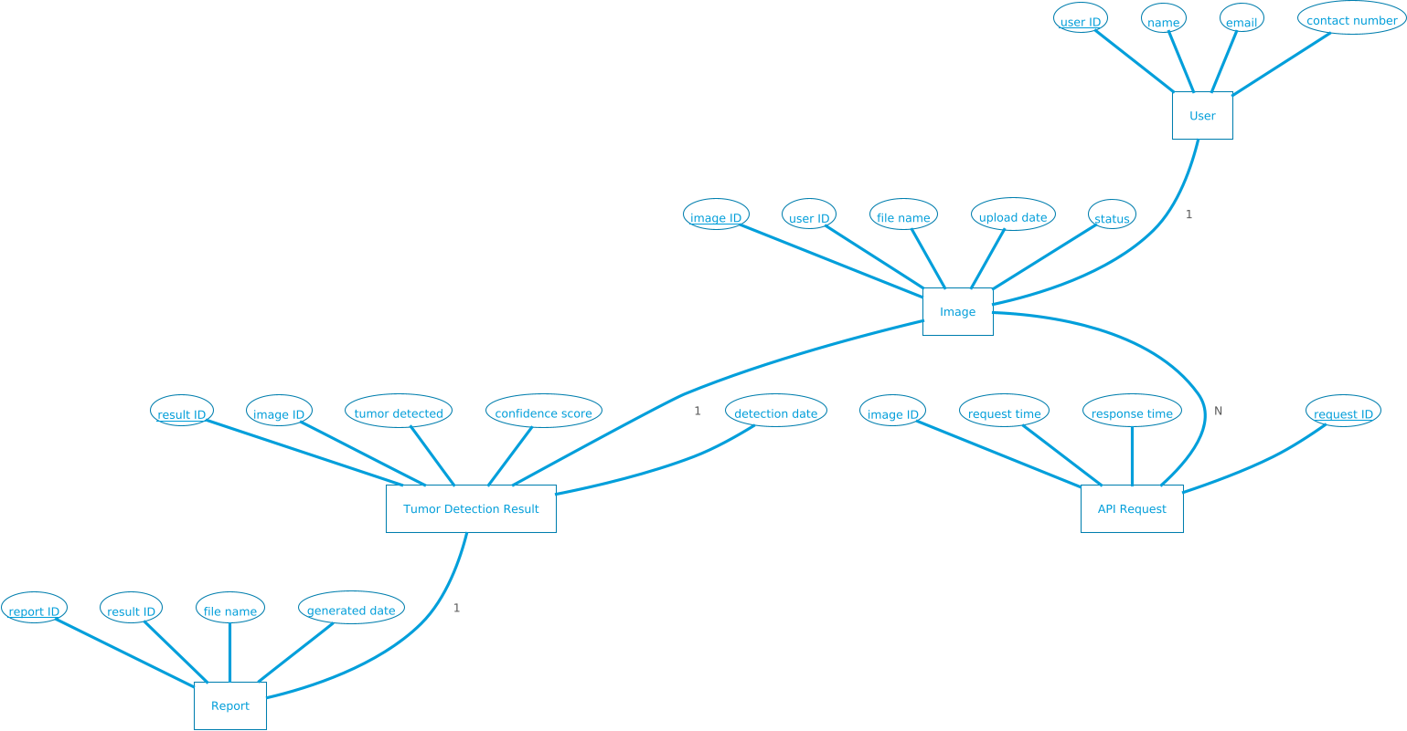

Figure 4.3: ER diagram for the Brain Tumor Detection

Figure 1.4 shows the relationships between User, Image, Tumor Detection Results, and Report entities in the brain tumor detection system. It illustrates how users upload images, which are processed to detect tumors, and generate corresponding reports.

Database Schema for Brain Tumor Detection System

This schema is tailored for saving images, processing them, and storing the results. It includes the essential tables for your requirements.

Image
Imageid INT
Filename Varchar
Filepath Varchar
uploadDate dateTime
Status ENum

Tumor detection Result
Resulted INT
Imageid INT
Tumordetected Bolean
Confidence score Decimal
Detection date DateTime

Figure 4.4: Database Schema for Brain Tumor Detection

Architectural Diagram for Brain Tumor Detection System

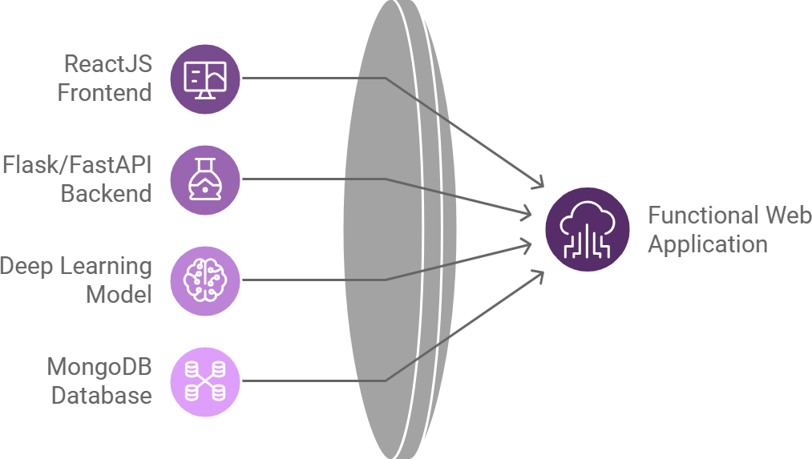

Figure 4.5: Architectural Diagram for Brain Tumor

- User Interface (UI) Layer
  - Purpose: Allows users to upload MRI image and download the result/report.

Components:
    - Web application or mobile app interface.
    - Provides options for image upload and report download.
  - Technology: React.js, HTML, CSS.

Application Layer
  - Purpose: Handles application logic, API communication, and user requests.

Components:
    - FAST API for communication between frontend and backend.
    - Image preprocessing and validation.
  - Technology: FastAPI, or similar frameworks.

Processing Layer
  - Purpose: Processes images using AI models and generates results.

Components:
    - Deep Learning model (e.g., TensorFlow).
    - Tumor detection logic.
  - Technology: Google Colab, trained neural networks.


Figure 4.6: Number of images in each category

Data Layer
  - Purpose: Stores uploaded images and their associated results.

Components:
    - Database for image metadata and results.
    - File storage for images and reports.
  - Technology: MongoDB.

Output Layer
  - Purpose: Provides the final result to the user.

Components:
    - Report generation.

5.1 Graphical User Interface

Home page Section
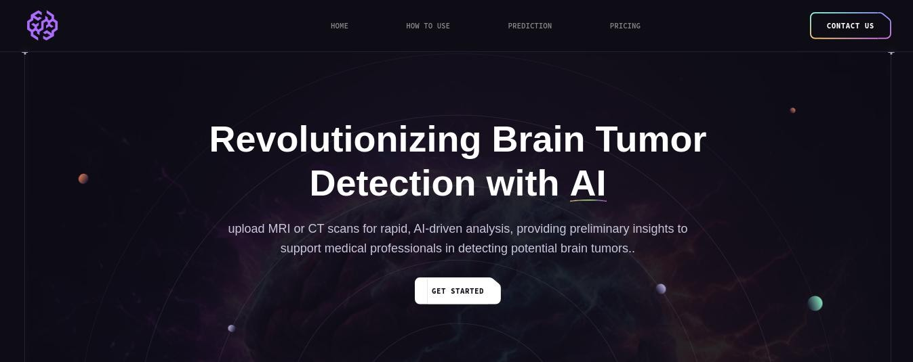

Home page Section 2
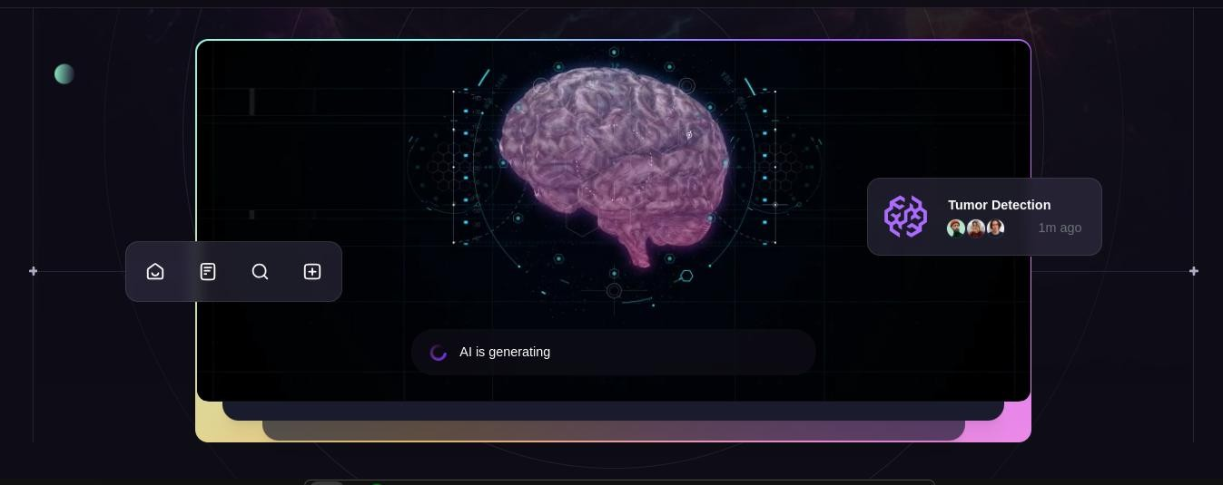

Types Info on HomePage

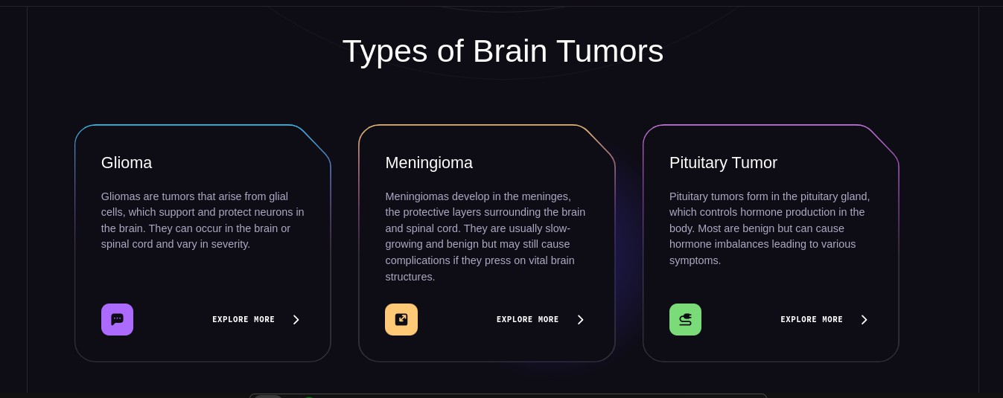

Import Image Section Empty Report Section
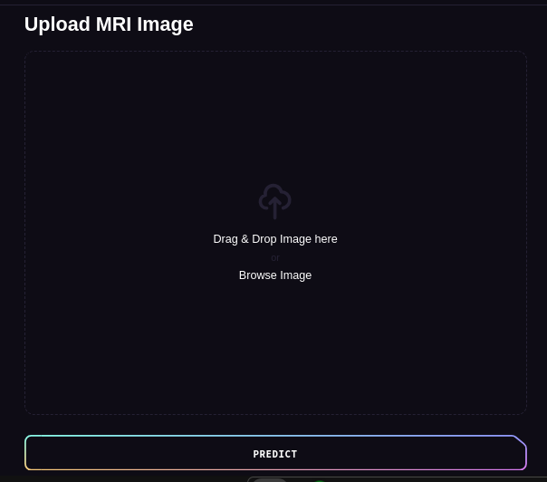


Showing Report of Tumor Detected
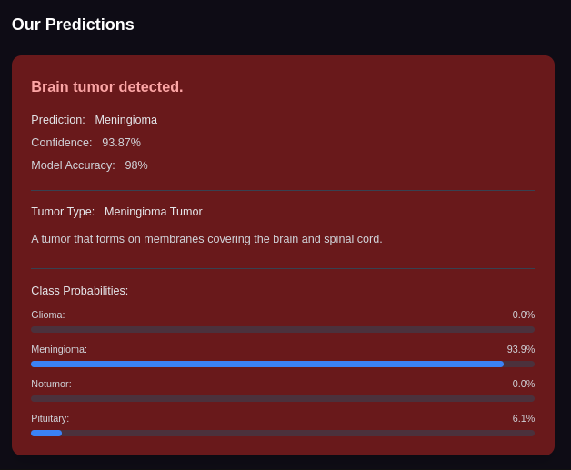

Showing No Tumor Detected
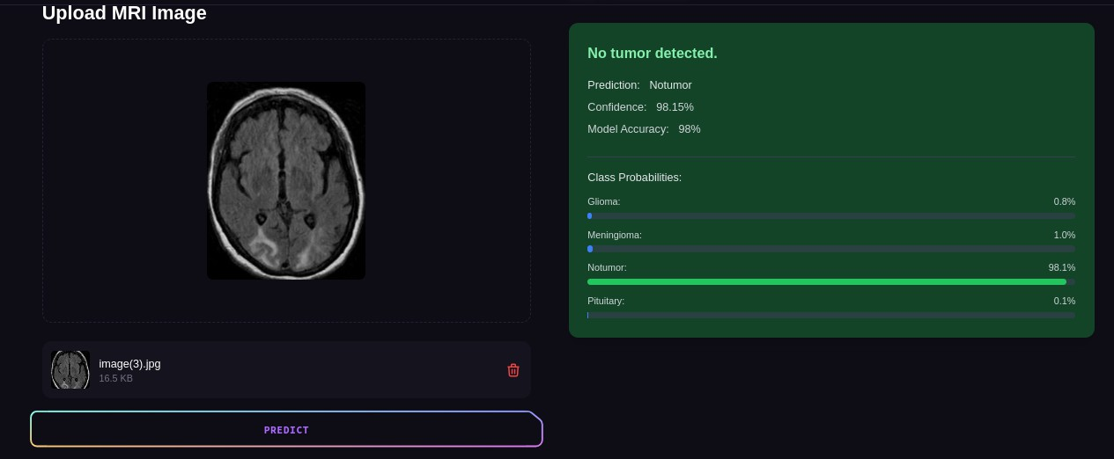

Showing Tumor Detected
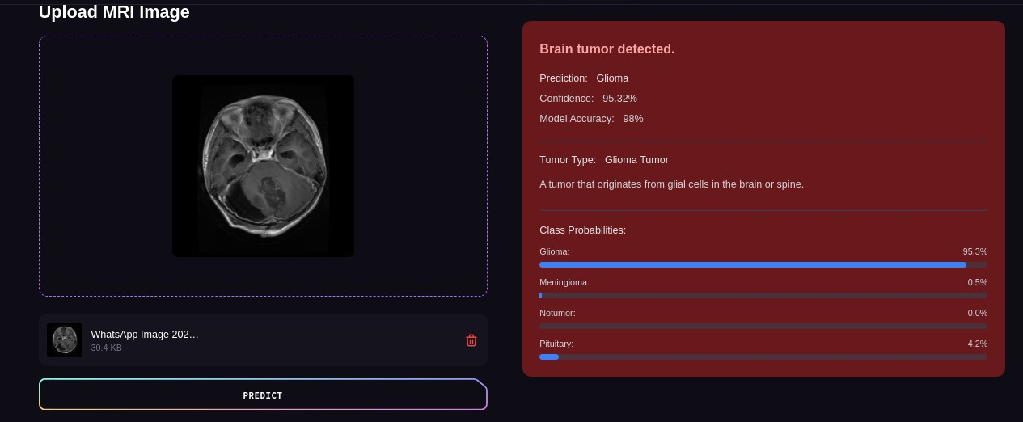

Introduction
Welcome to the testing phase of the TumorTech AI-Powered Brain Tumor Detection System. This critical stage ensures the AI model, web interface, and backend logic all perform seamlessly. Testing focuses on image uploads, tumor detection accuracy, API responsiveness, and report generation. The goal is to verify system reliability, performance, and usability for healthcare professionals relying on timely and accurate results.

Test Scenario

Test Case ID: 01
Test Case Name: Image Upload
Test Priority: High
Preconditions: User must have an MRI image.

Post conditions:
- Image is uploaded to the server.
- Image is stored and ready for preprocessing.

SN | Action | Inputs | Expected  Outcome | Actual  Output | Test  Application | Test  Result | Test Comments
1 | Launch UI | Web application | App loads with upload  feature | Upload feature visible | Google Chrome | PASS | [Rizwan 01/04/2025]: Loaded correctly
2 | Upload valid image | DICOM/P NG MRI  file | Image upload success, moves to  preprocessing | Image uploaded successfully | Chrome | PASS | [Talha 01/04/2025]: Working fine
3 | Upload invalid  file | JPG of landscape  image | Error message  shown | Error: Invalid image type | Firefox | PASS | [Talha 01/04/2025]: Validation good

Test Case ID: 02
Test Case Name: Tumor Detection
Test Priority: High
Preconditions: Image must be preprocessed and stored.

Post conditions:
- AI model returns tumor detection results with confidence score.

SN | Action | Inputs | Expected  Outcome | Actual Output | Test  Application | Test  Result | Test Comments
1 | Send image to model | Preprocessed MRI scan | Tumor areas highlighted with  confidence | Tumor: Glioma, Confidence: 94% | Chrome | PASS | [Rizwan 02/04/2025]: Model works fine
2 | Cancel mid- process | Stop process | Cancel message | Tumor detection  canceled | Chrome | PASS | [Talha 02/04/2025]: Message displayed
3 | Send corrupted  file | Broken file | Error message | Detection failed, retry  prompt | Chrome | PASS | [Rizwan 02/04/2025]: Error handled well

Test Case ID: 03
Test Case Name: Report Generation
Test Priority: Medium
Preconditions: Tumor detection must be completed.

Post conditions:
- PDF report is generated and downloadable by the user.

SN | Action | Inputs | Expected  Outcome | Actual Output | Test  Application | Test  Result | Test Comments
1 | Click Generate  Report | Tumor results with  metadata | PDF report created with  details | Report with detection & score  generated | Chrome | PASS | [Talha 03/04/2025]: Report created fast
2 | Report  Show | Can show  the Report | Report | Showing all aspects  of Report. | Chrome | PASS | [Rizwan 03/04/2025]:  File valid and clear

Test Plan Summary

Test Policy:
Testing covers the entire system including Image Upload, Tumor Detection, Report Generation, API responses, and UI/UX performance.

Objectives:
    - Ensure reliable tumor classification
    - Confirm quick response time
    - Validate report accuracy
    - Secure data transmission

Test Strategy:
    - Functional Testing
    - Compatibility Testing
    - Usability Testing
    - Performance Testing
    - Security Testing

Environment:
    - Devices: Desktop browsers
    - OS: Windows 10, Ubuntu
    - Browsers: Chrome, Firefox
    - Tools: Google Colab (model), Postman (API), MongoDB Compass (DB)

Test Schedule:
    - Week 1: Image Upload & Preprocessing
    - Week 2: Tumor Detection
    - Week 3: Report Generation & Integration Testing

Risks & Contingencies:
    - Model failure → fallback retry logic
    - Browser compatibility → cross-browser testing
    - Corrupt uploads → file validation

Chapter 7: Future Work & Conclusion

Future Work
    - Real-Time Analysis: Optimize models for faster results.
    - Multi-Modality Support: X-ray support.
    - Advanced Visualization: Allow 3D tumor rendering.
    - User Dashboard: Track patient image history.
    - Mobile App: Extend access on Android/iOS.

Conclusion:
The TumorTech AI system represents a significant leap forward in automating brain tumor detection. The project successfully achieved image upload, tumor analysis, and detailed reporting through deep learning integration. With proper testing and future upgrades, this platform holds the potential to aid healthcare providers in early detection and effective patient management.

